 | 10.1.5 Editors - Compositor Editor - Header - Add Menu
Table of content
Add menu 1
Add menu - Search 1

Add menu

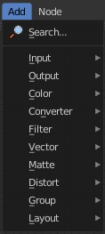
Here you will find all the nodes that you need for compositing. A click at one of the items will create the node in the workspace at the mouse position right under the menu. It is already selected, and you can drag it around.
Note that the content may differ, dependent of which renderer you use. Some nodes just works with specific renderers. They will be marked as such.

Note also that some shaders are real resource hogs, and can slow down rendering times significantly.

Add menu - Search

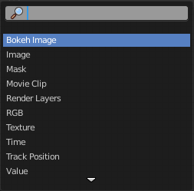
This is a search menu where you can search for specific node types in all categories.

